Type-2 Diabetes
Course
Name

Type-2 Diabetes
Introduction
Diabetes is a constant illness that happens either when the pancreas doesn't create sufficient insulin or when the body can't adequately utilize the insulin it produces. Insulin is a chemical that controls glucose. Hyperglycaemia, or raised glucose. With type 2 diabetes the body doesn't utilize insulin well and can't keep glucose at typical levels. Side effects may not be discernible thus essential to get the glucose tried if one is in danger. This kind of diabetes is generally the consequence of an abundance of body weight and actual dormancy subsequently can be forestalled or deferred by solid way of life changes, for example, getting in shape, eating good food, and being dynamic (Healthy People, 2020).
Over 34 million individuals in the United States have diabetes, which is likened to 10.5% of the populace. 1 out of 5 of them does not realize they have it. Of the 34 million individuals living with diabetes; 90% - 94% are determined to have Type II diabetes. Gestational diabetes expands the danger for type 2 diabetes later in life after the infant is born. The infant is bound to have stoutness as a kid or adolescent and bound to create type 2 diabetes further down the road as well. 88 million grown-ups have prediabetes. Be that as it may, over 84% are undiscovered.
With prediabetes, glucose levels are higher than typical, yet not sufficiently high yet to be analyzed as type-2 diabetes. Prediabetes raises your danger for type 2 diabetes, coronary illness, and stroke. Throughout the long term, the quantity of grown-ups determined to have diabetes has dramatically increased as the American populace has matured and turn out to be more overweight or hefty. Additionally, presently diabetes is progressively habitually in youngsters. Diabetes is the seventh driving reason for death in the United States (Healthy People, 2020).
Healthy People 2020 Goal
- “Reduce the disease burden of diabetes mellitus (DM) and improve the quality of life for all persons who have, or are at risk for, DM” (Healthy People, 2020).
Risk assessment for the patient in clinical case study
Jane Smith not her real name a family friend, is a 50 years of age woman from the Asian descent. She is a heavy smoker, obese and has high blood pressure and admits to living a sedentary lifestyle. Her family has never been diagnosed with diabetes however she has polycystic ovary syndrome. With her record of lifestyle and physical and social history she is at high risk of getting Type 2 diabetes. However, after being screened she has been trying to live a healthier lifestyle by going to therapy to quit smoking and Regular exercise helps with several risk factors. It helps you lose weight, helps keep your cholesterol and blood pressure under control, and helps your body use insulin.
Risk Factor (Diabetes UK, n.d.)
- Overweight or obese
- Age 45 or older
- High blood pressure
- Not physically active
- Polycystic ovary syndrome
References
Diabetes UK. (n.d.). Diabetes risk factors. https://www.diabetes.org.uk/preventing-type-2-diabetes/diabetes-risk-factors
Healthy People. (2020). Diabetes | Healthy People 2020. Healthypeople.Gov. https://www.healthypeople.gov/2020/topics-objectives/topic/diabetes


Primary Prevention of Diabetes

WHAT IS DIABETES?
- A chronic disease in which the body produces insufficient or no insulin which causes elevation of blood glucose levels.

GENERAL FACTS

- Almost sixteen million people in the United States have either Type 1 or Type 2 diabetes.

- A person is diagnosed with Type 1 diabetes if their body does not produce insulin.

- Type 1 diabetes occurs mostly in young children and young adults.

- A person is diagnosed with Type 2 diabetes if there body resist insulin. The body begins to overwork its self by producing excess insulin.

- Type 2 diabetes occurs mostly in older adults but is becoming more common in younger generations.

- 95% of the people diagnosed with diabetes have Type 2.

EATING HEALTHY
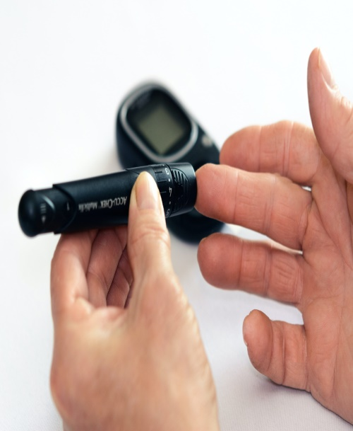

The initial step to practicing good eating habits is figuring out how a lot you ought to eat. Eating sound with diabetes is significant on the grounds that it controls blood glucose levels.
A smart dieting plan that is normally wealthy in supplements what's more, low in fat and calories. Key components are natural products, vegetables and entire grains.




EXERCISE

Exercise is essential to those with diabetes. People with Type 2 diabetes are usually overweight. If the person can maintain a healthy weight their blood glucose levels will regulate. Exercise helps with the use of insulin in the body.
Exercises that can be done:
- Walking/Running
- Dancing
- Swimming
- Bicycling

It is recommended to exercise at least 30 minutes daily. If starting off one could work out for 10 minutes 3 times daily.

Make exercising fun! Find others that are trying to reach a goal.


REFERENCES
Diabetes UK. (n.d.). Diabetes risk factors. https://www.diabetes.org.uk/preventing-type-2-diabetes/diabetes-risk-factors
Healthy People. (2020). Diabetes|
Healthy People 2020. Healthypeople.Gov.
https://www.healthypeople.gov/2020/topics-objectives/topic/diabetes

